Work to Worker
(Services to unorganized sector)

SRS Version 1.0

Team Guide Team name-
Mr.Amit Kuraria TechLearners

Team Members College name
Prakash Chourasia HCET,Jabalpur
Yagya Narayan Goyal

Table of Contents
1. Introduction
1.1 Purpose
1.2 Scope
1.3 Definitions, Acronyms and Abbreviations
1.4 References
1.5 Technologies used
1.6 Overview
2. Overall Description
2.1 Use Case Model Survey
2.2 Class diagram
2.3 Tree of System
2.4 ER Diagram
2.5 Data Flow Diagram
2.6 Assumptions and Dependencies
3. Specific Requirements
3.1 Use Case Reports

Software Requirements Specification

1.0 Introduction
Work to Worker - Services to unorganized sector-
System is to providing a work to worker. Solution focused on the workers of unorganized sector includes mason, carpenters, gardener, painter etc. Work to Worker is a Web-based solution through which worker (s) registered them selves for a specific skill. Using this system general public or organized sector user can select the worker(s) as per their need.
1.1 Purpose
Conventionally the citizen and organization has many problems to get the good workers as per need and finally they compromise with workers. Here we have provided a facility where citizen can make their profile and then request for corresponding work to get worker.
Similarly an worker usually have problems in finding appropriate work ,so system will help him by sending an immediate SMS and he can responds to it.

1.2 Scope

- Create different workers and they get corresponding work.
- Maintain a centralized database to provide security to information which can be accessed only by the admin.
- Workers logs on to his account to view work details.
- Supervision of no. of workers required by user. This customizable feature allows admin user to provide required amount of workers.
- Worker can be rate, can get remarks for his work and also report & graph generating feature.
- Maintains history of the rating and remarks of last five provided works.
- Track all the information of Workers &Users and their contact details.
- All users are authenticated to avail the service.
- Java based client for Administrator Interface to admin to change static web contents.

1.3 Definitions, Acronyms and Abbreviations
- Admin – Administrator (super user), he is the controller of all the employees, citizens and maintaining all records of the citizen and employees.
- Workers– Waiter, Mason, Carpenters, Gardener, Painter, Busboy, chef, Labour etc from the society.
- Users – General public, Any Organization, those who only registered in this site.
- HTML – Hypertext Markup Language is to create static websites.
- J2EE – Java 2 Enterprise Edition is a programming platform and it is the part of the java Platform for developing and running distributed java applications.
- Mysql – Mysql is the database management system that provides a flexible and efficient database platform to erect strong on demand business applications.
- HTTP – Hypertext transfer protocol is a transaction oriented client/server protocol between web browser and a web server.
- HTTPS – Secure hypertext transfer protocol is a hypertext transfer protocol over secure socket layer.
- TCP/IP – Transmission control protocol/internet protocol is the communication protocol used to connect hosts on the internet.
1.4 References
- IEEE SRS format
- Project specification requirement (provided by IBM)

1.5 Technologies used
- HTML – Hyper Text Markup Language
- Java Script – Script Language
- JAVA – Application architecture
- J2EE – Application architecture

1.6 Tools used
- Mysql – Database
- Netbeans 6.8
- JSP – Java server Pages
- Servelets

1.7 Overview
SRS includes two sections overall description & specific requirements Overall description will describe major role of the system components and interconnections. Specific requirements will describe roles & functions of the actors.

2.0 Overall Description
2.1 Use-case model survey

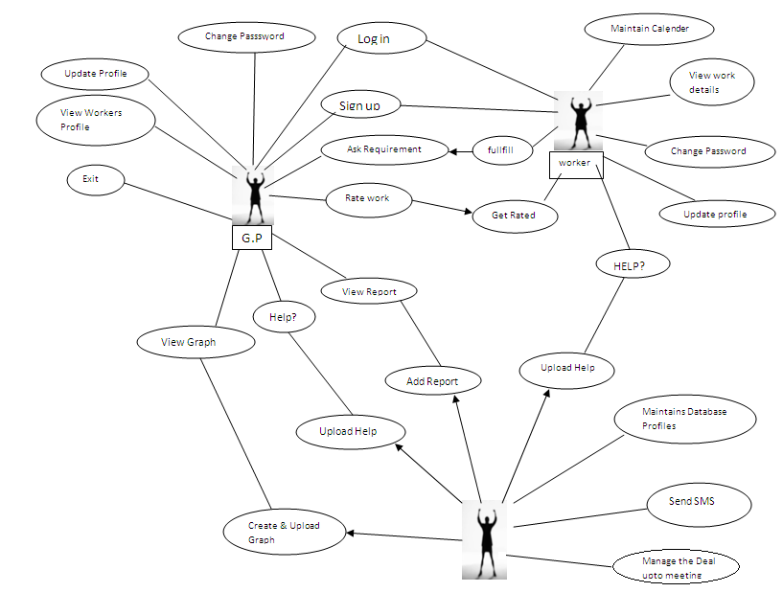
Admin.

2.2 CLASS DIAGRAM
Interface for Rating
Workers
Administrator
Users
User name
Password
Worker-id
Name
Email
Age
Address
Mobile no.
Password
Job
Gender
Working Area
Payment mode
Daily charge
Specialized-work
Rating id
Remarks list
Rating marks

Email
Password
Name
User –id
Mob. – Mgr.
Address
Employee-name
Emp-id
Site mobile No.

Rating-id
Worker-id
Rating marks
Remark

Sign-in ()
Delete profile ()
Generate report ()
Generate graph ()
Upload Report ()
Upload graph ()
Manage User Profile ()
Manage Workers profile ()
Sending SMS ()
Manage Deal ()

Functions
Date ()
View workers Profile()

Functions
Sign-up ()
Sign-in ()
Update profile ()
View workers profile ()
Rate ()
Require ()

Interface Require
Work details
(Interface)

Request no.
No. of workers
Mode of work
Name of work
starting-date
Ending-date
Site-address
Wage-range
User-id

Name of work
Reg. no.
User-id

Functions
Update profile()
Sign up ()
Sign in ()
Change password()
Manage calendar ()
View work detail ()

Function
View ()

Functions
Submit ()
New work()

2.3 Tree of System

Works to workers

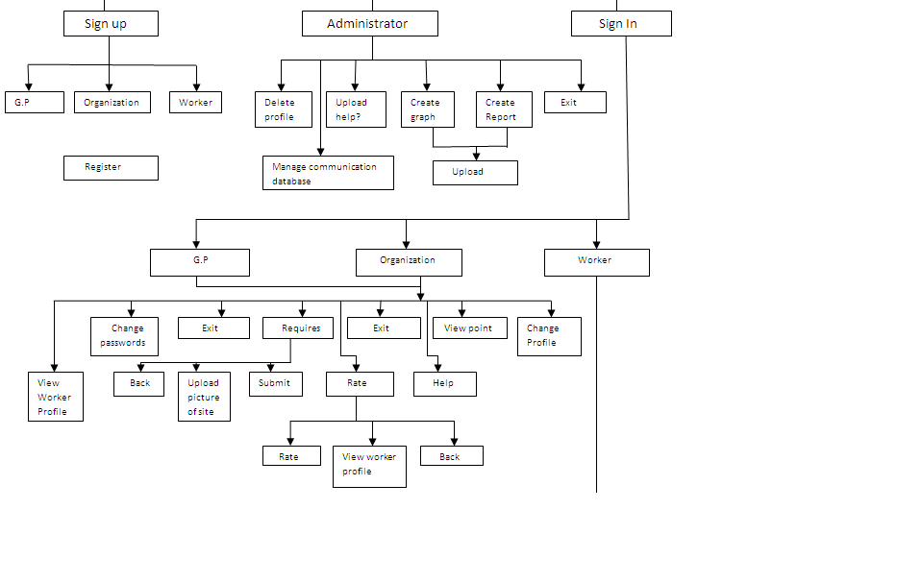
Exit
Change Password
Change Update Diagram

View worker details
Manage Calendar

2.4 ER DIAGRAM

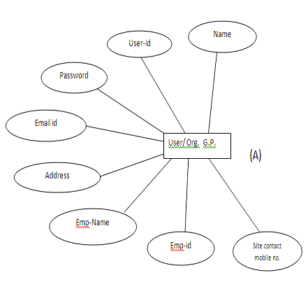

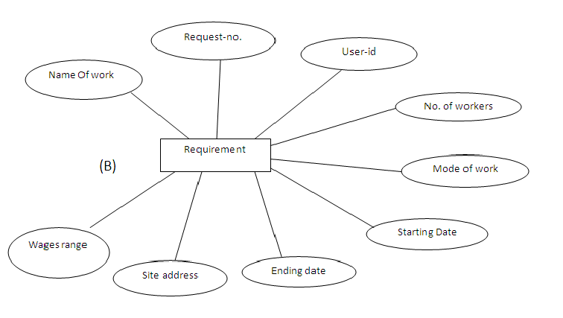

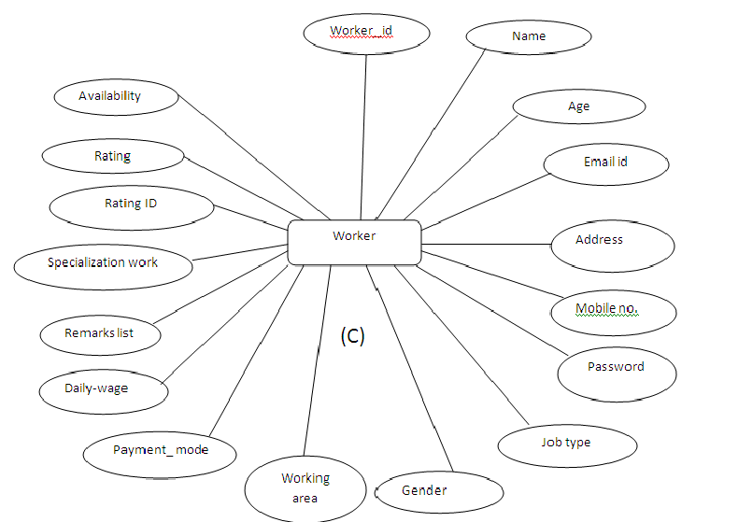

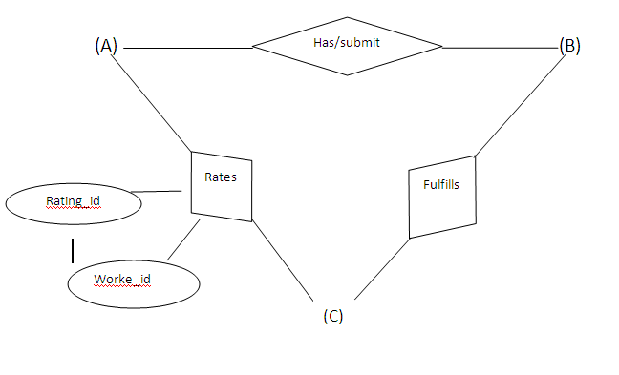

2.5 Data Flow Diagram

LEVEL 0

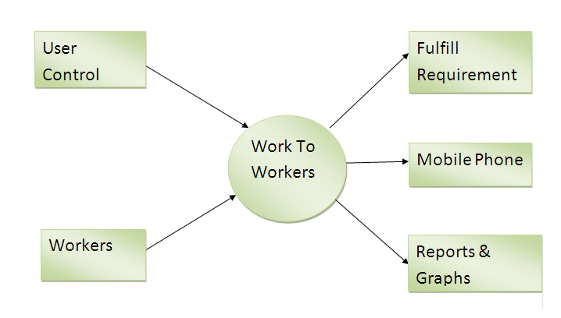

Level 1 DFD

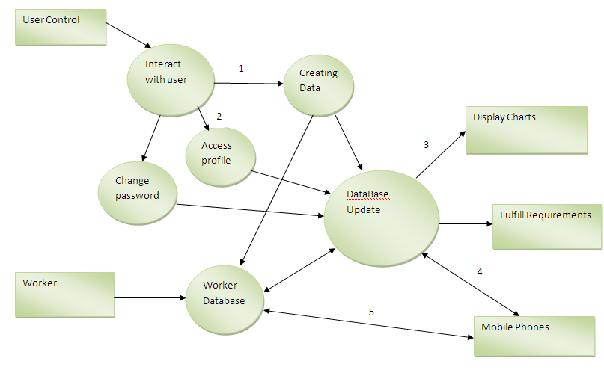

Level 3 DFD
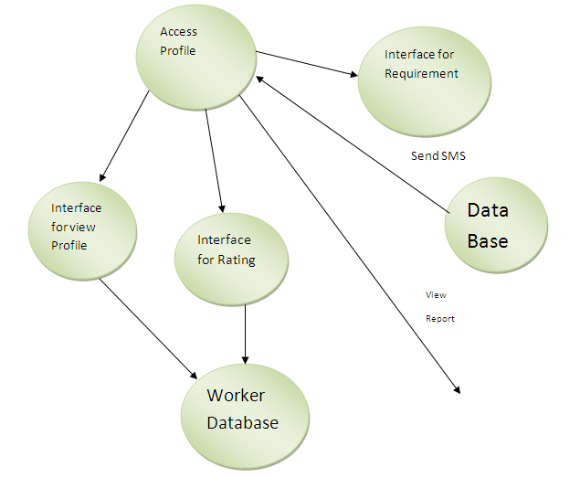

2.6 Assumptions and Dependencies
- The end user should have a basic knowledge of English and computer usage.
- The end user should be able to scan the required documents and upload while applying for various licenses and for creating account.

3.0 Specific Requirements

3.1 Use-case reports
End user
- Sign up
In order to use the system user/(worker,general public,organization) must sign up by filling the sign up form.
- Sign in
After getting the username and password etc. according to type of user, end users can log on to their account and can access the website.
- Open profile
End user can open their profile which contains the personal details which he/she provided during sign up.

- Update profile
End user can update their profile which contains the personal details which he/she provided during sign up if any update required.
- Request for Worker
End user who signed in can request for various workers for many works each work is assign a request number.
- View Worker Profile
End user who signed in can view the workers profile i.e rating,remarks given by previous consumers e.t.c using worker id.
- Open requested/requirement forms
End user who signed in can open the requisition form and after viewing it he/she can close the form without submit.
- Enter details
End user who signed in can open the requisition form and enters the mandatory details required in that form.
- Submit form
After filling the mandatory and other details, End user submits the form.

- Rate an Worker
End user can rate a worker who works for him,worker will give rating id to the user for whom he woks.
- View Report and graphs
End user who signed in can view the reports and graphs which shows the system utilization.
- Help
End user or worker all can get the help if any problem is there.
Worker

- Sign up
In order to use the system worker must sign up by filling the sign up form.
- Sign in
After getting the username and password etc. according to type of user, end users can log on to their account and can access the website.
- Open profile
Worker can open their profile which contains the personal details which he/she provided during sign up.

- Update profile
Worker can update their profile which contains the personal details which he/she provided during sign up if any update required.

- View Details of Work
Worker can view details of work provided by user using request no. provided by admin in an SMS

- Manage Calender View Details of Work
Worker can manage his calendar.

Administrator
- Verify details:
Admin authenticates all the end users and officers by checking their username and password.
- Provides login account:
After getting the sign up details from the end user, Admin provides the username and password etc.to the end user that should be kept for future login and also admin checks for uniqueness.
- Maintains system server:
Admin. maintains centralized system server which controls the client computers.
- Maintains database:
Admin maintains the entire database and he is the only authorized person to add/remove/edit Users and workers.
- Sending SMS
Admin. Will send SMS and e-mails to the appropriate worker according to requirement,and worker will respond to it accordingly details of workers is send to user via e-mail or an SMS.and later both can fix meeting according to their understanding, Admin. Will manage the deal upto fixing a meeting..

- Add Report and Graphs details
Admin adds the reports and Graphs details to site which are generated by himself on the bases of popularity and system utilization.

